**Up In the Clouds**

1. Delete Sprite 1 (the cat)
2. Create a variable Score and make it visible to the stage.
3. Create a backdrop as a bitmap. I loaded a premade backdrop (Blue Sky 2) and added the grass.

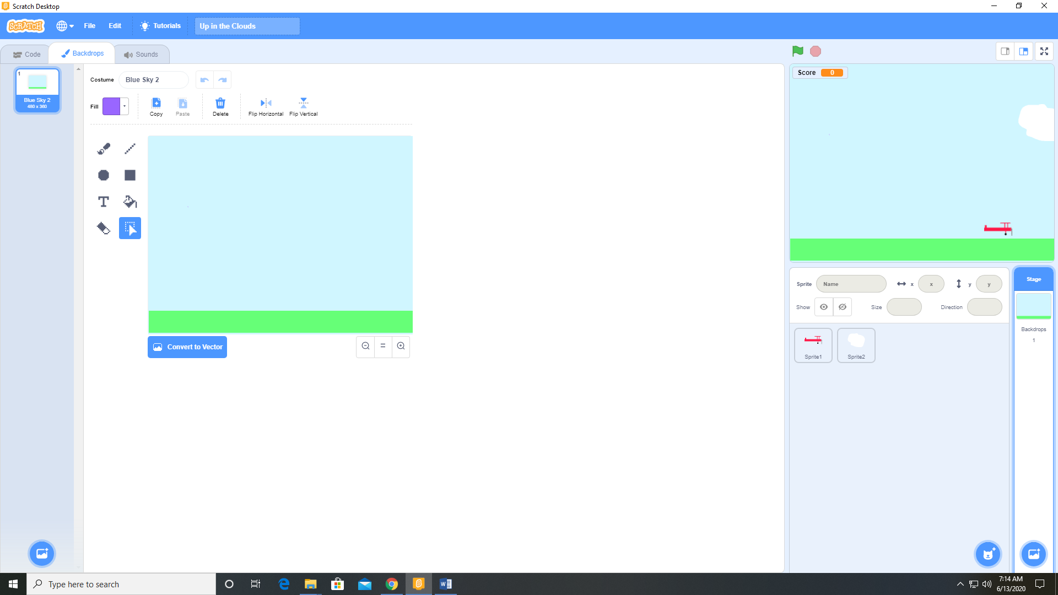

1. Paint a new sprite Airplane as a vector. This is Costume 1.

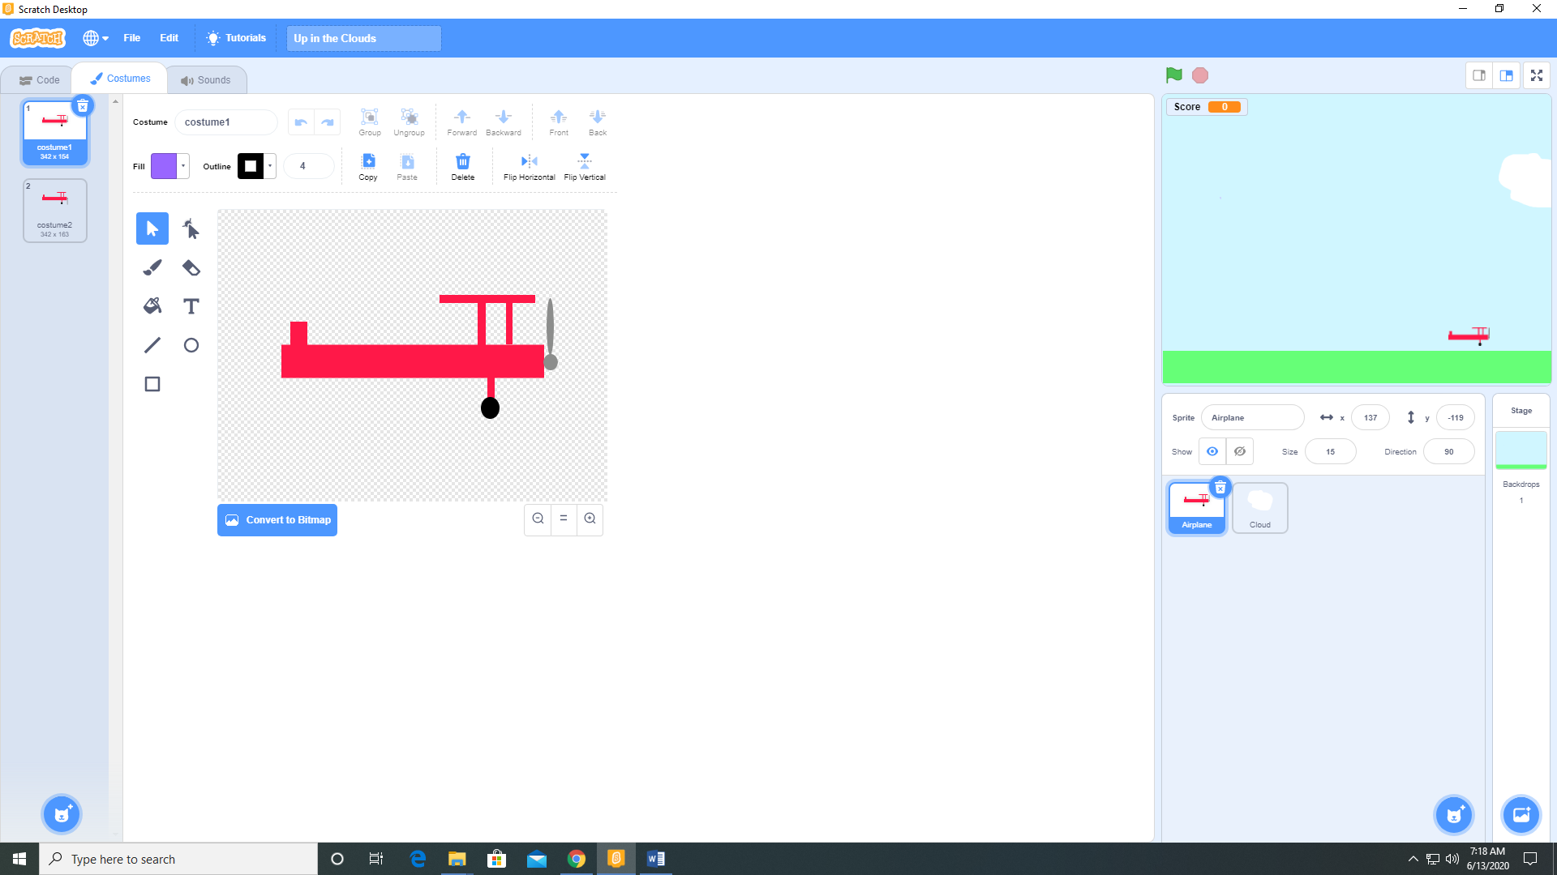

1. Right click on Costume 1 and select Duplicate to create Costume 2
2. Modify Costume 2

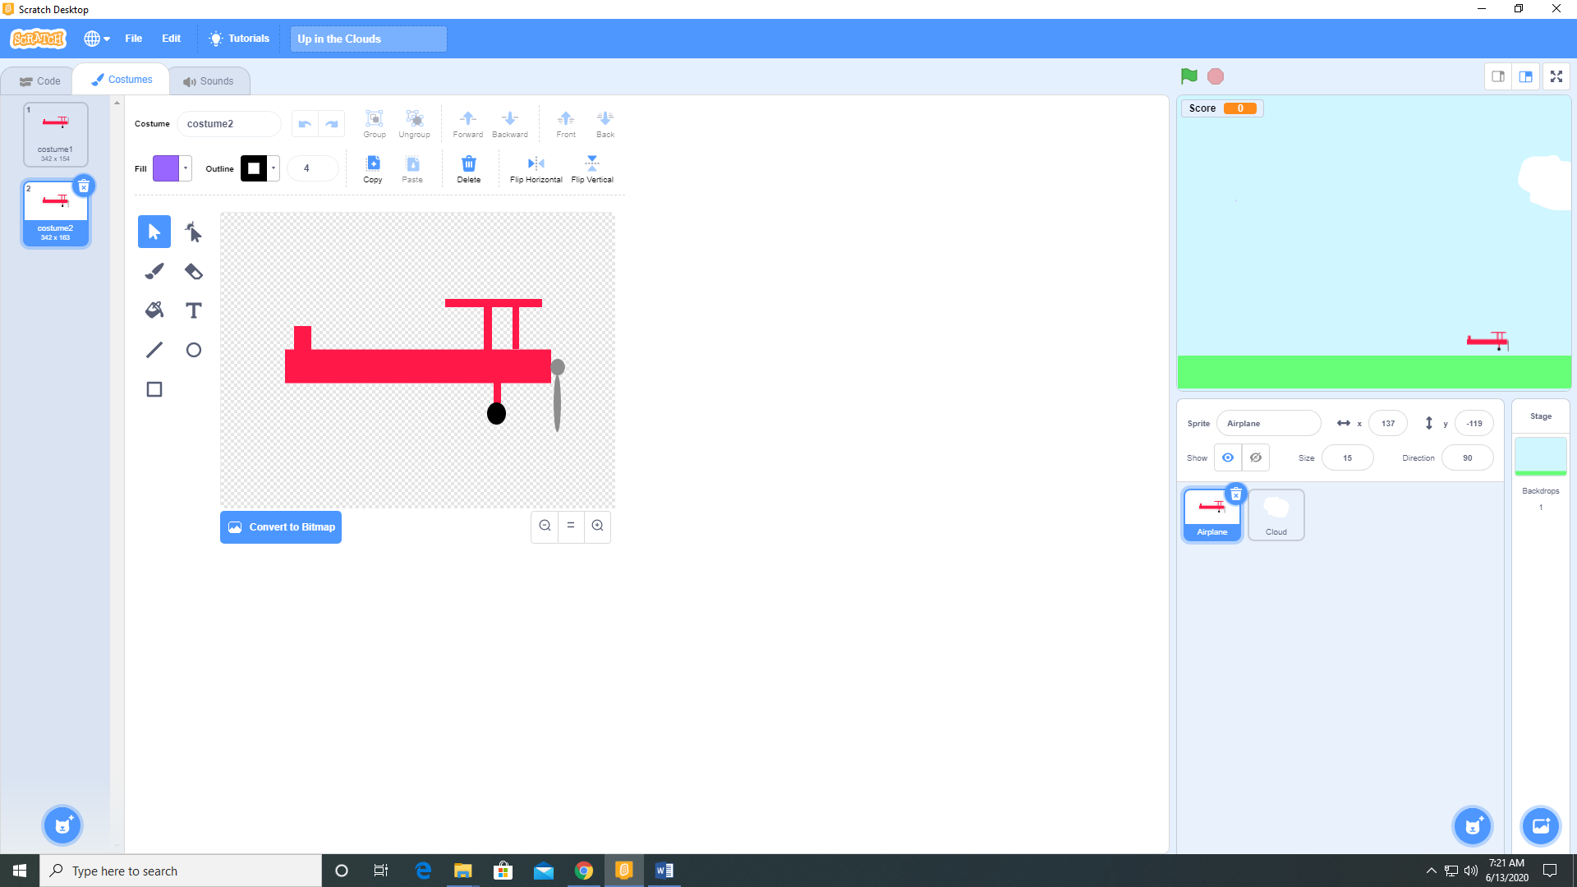

Note: All you have to do is move the propeller blade downward. This is the reason why I made this sprite a vector graphic. By having 2 costumes for this sprite, we can animate it.

1. Paint a new sprite Cloud as a bitmap.

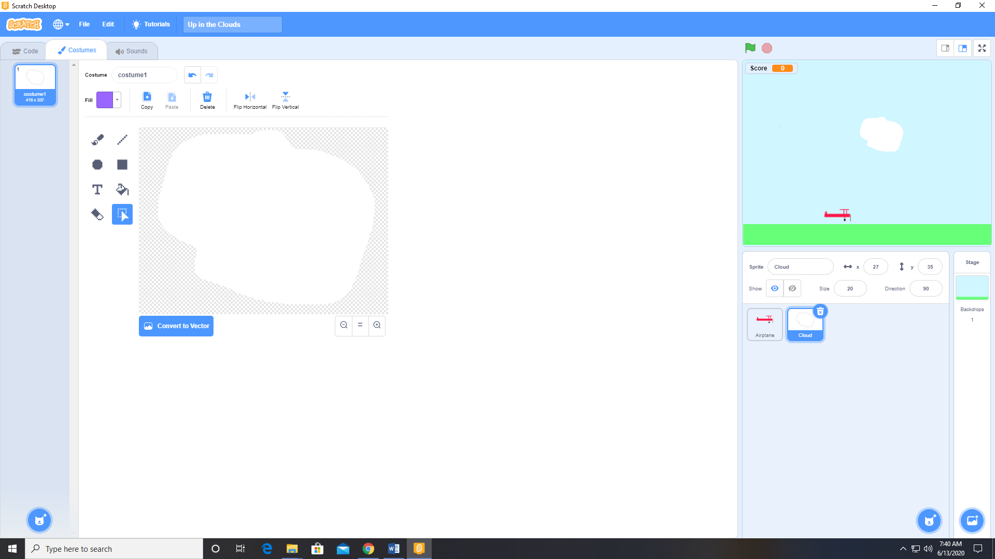

1. Add the following code to the Airplane sprite.

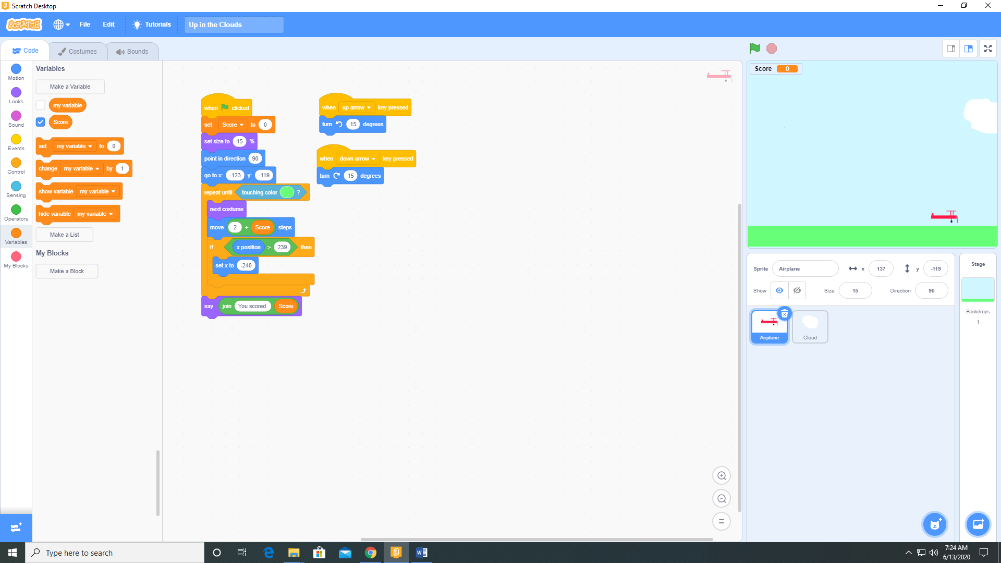

1. Add the following code to the Cloud sprite. Also add the Water Drop sound from the sound library.

